CAPM NOTES
What is BTP and Cloud Foundry >
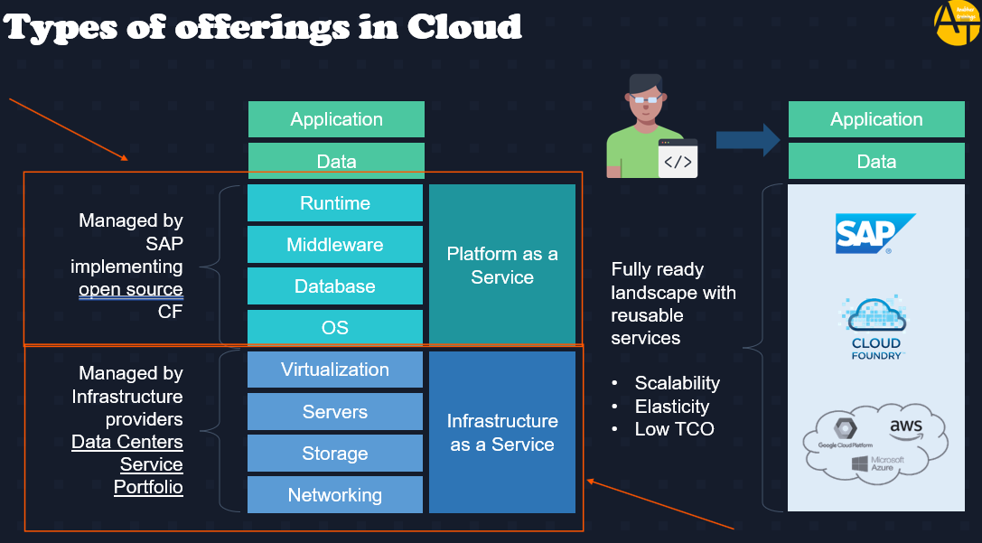
Basically on-Prem means we have to handle everything on our own that mentioned on above screenshot, and in case of cloud we get 3 options – IAAS, PAAS and SAAS. BTP is a PAAS basically SAP partnered with Amazon AWS, Azure cloud provider and form the IAAS and for PAAS SAP took open-source code of Cloud Foundry and did changes on top of it like adding Hana, ABAP runtime and others and made the whole thing as SAP cloud platform Known as BTP, where we can made application and deploy on it.
Cloud Foundry – It’s a Platform as a Service and also, it’s an open source, provided by Pivotal. Remember SAP has built on top of Cloud Foundry platform and make a Cloud Platform called BTP.
>> SELF HEALING MECH In BTP each application that we deploy executes in a self-healing mechanism called cell, in cell we have containers (application + runtime) which runs the application, if any container got stop then in cell, we have cell wrap which call CF engine and CF engine create another cell and garden and container and runs another instance of that application.
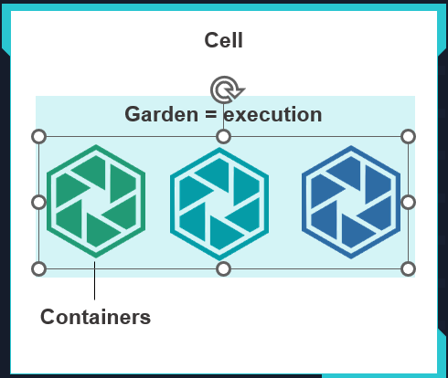
BTP ORG Structure > Very IMP
BTP has global account at start like for example IBM is an organization and it will have Global account while purchasing BTP services, but for its various subsidiaries say in US it has one, where they are doing all Finance related works, another in India where doing HR related and in Canada where doing Operations related. Then this subsidiaries or department will have Sub-account which will consist of 1 data center according to location. Then say if US IBM subsidiary has 2 Parts in same place, another one working in Sales then this will be handled by Dictionary (it’s a group of Sub-accounts). Space Quata is nothing but Dev, Test and Prod environment separations within the subaccount.
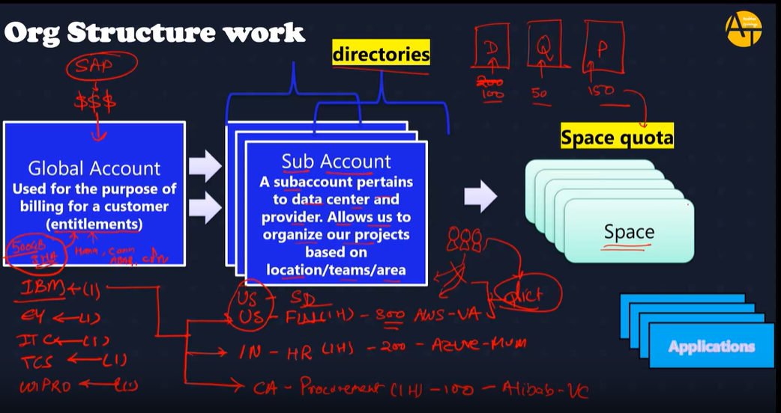
Environment, Subs and Instance (Services) –
Environment is nothing but the actual platform-as-a-service offering of SAP BTP that allows for the development and administration of business applications.
SAP BTP offers three environments: ABAP, Cloud Foundry and Kyma.
Subs and Instance are service provided by SAP BTP, subs are like URL which we can use for example SAP BAS, instance is nothing but the connection, auth, databases. Which we can use. Instance Service Requires Service Key after installing instances. Service Key will have all the passwords, information to talk to Db.
Steps to deploy any application in CF from VS Code >
- Open project in VS Code, Open corresponding Terminal.
- Type cf login -a “your api end point from btp” >> https://api.cf.us10-001.hana.ondemand.com/
- Then enter email and Password.
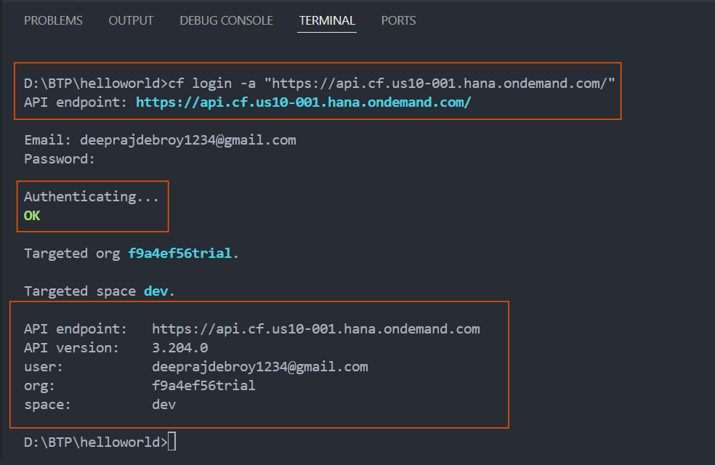
- We can check all the available runtime name in BTP CF using cf buildpacks
- Cf push – is used to deploy project to cloud foundry (here we are deploying go project)
- CF login
- CF apps
- CF scale APPNAME -m 2048M
- CF scale APPNAME -i 2
Above from 6 to number 9 is for scaling of apps when deployed to Cloud foundry, The increase in number of instances is horizontal scaling and increase in memory of instance is Vertical scaling.
Node Project Creation >
For any node project creation, we should follow below steps >
- Create a Folder then initialize the folder with node project – npm init (ui5 also we do it at start as it is also a node project)
- We create required file and add the reusable module from node library.
- Syntax to add – npm install -D nameOfModule / npm install -g nameOfModule
How to create a Server using express >
We first need to add express module, then we can use various methods provided by express.
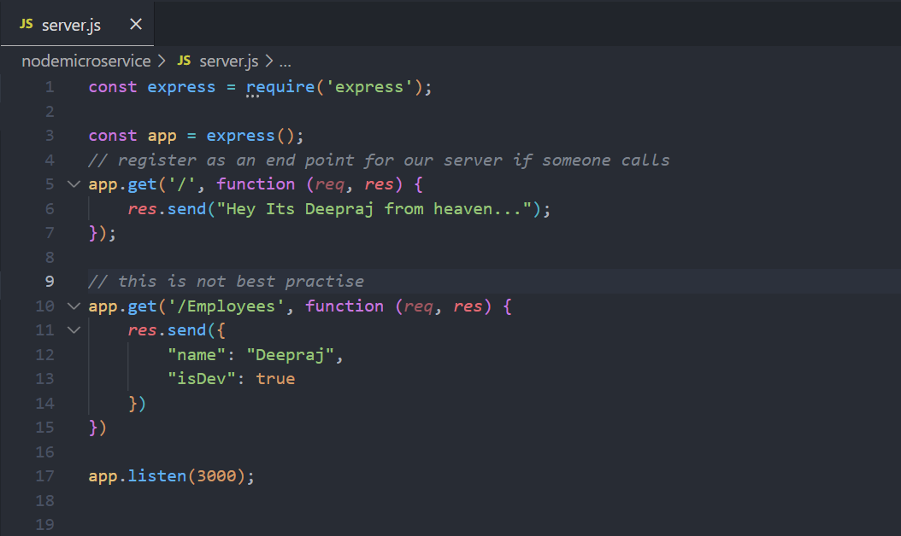
But we are sending Json directly as a response which is not correct way so we can create a new Folder called ‘webapp’ and can expose all the files inside it.
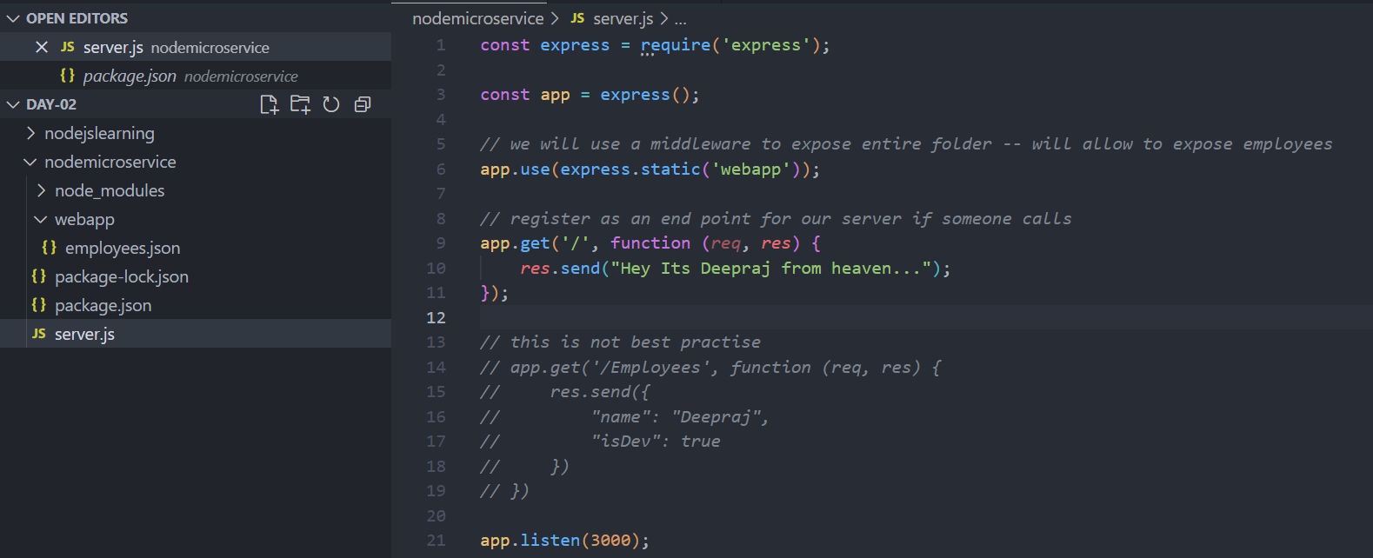
CAPM >
CDS >
Basically, we use CDS in CAPM because it helps mostly on changing DB, as if we use SQL and have MySQL Db then if we certainly want to migrate to HANA then need to change whole SQL code as syntax is different.
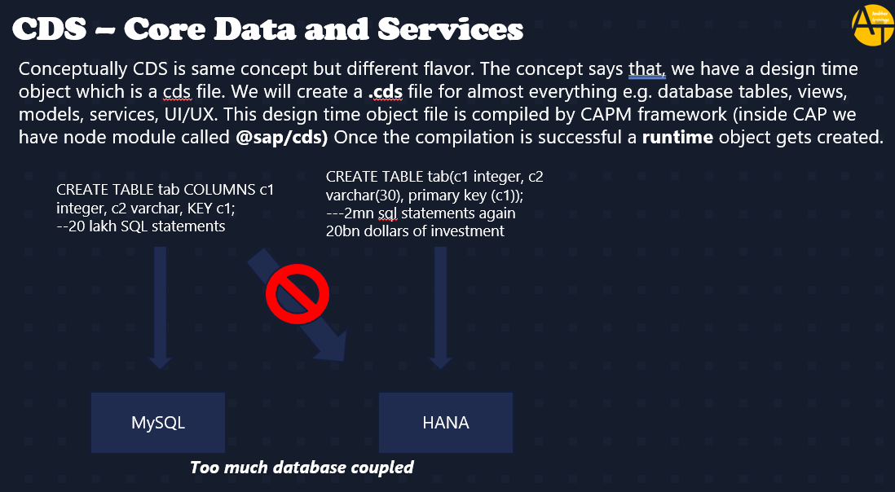
Solution -
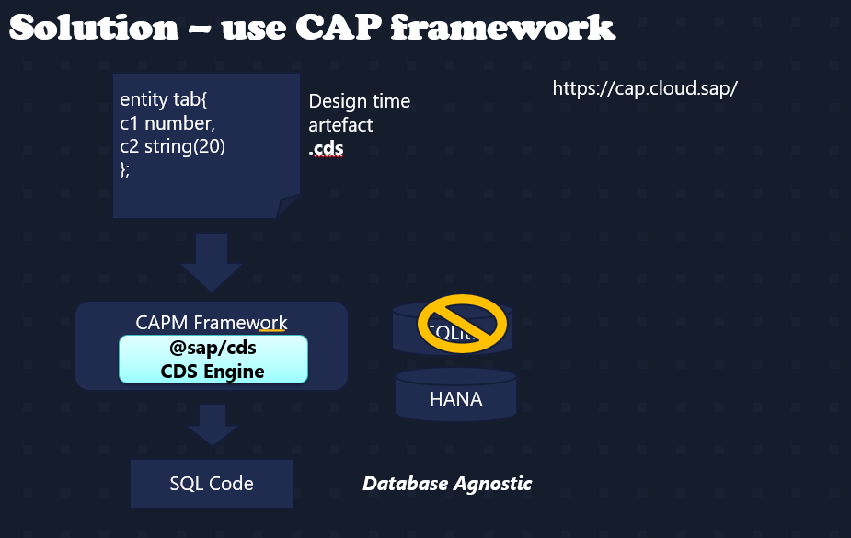
Basically, CAP framework @sap/cds helps to convert to the DB specific code.
Basic CAPM Project structure >
For creating basic CAPM project structure follow below –
- Create a Project Folder
- Go for CDS init for creating CDS project structure
- Npm install for installing all the dependency from package.json file.

